Instructions for facilitating coffee cup workshop online
The workshop should take no more than 20 minutes including:
- 2 minutes introduction
- 5 minutes round 1
- 5 minutes round 2
- 5 minutes reflection.
You will see there are 3 minutes grace for comments and delays throughout for you to use at your discretion. Realistically we anticipate the first round may take a little longer as people get the hang of the task.
Here is a link to a tester miro board, which others will have access to edit: https://miro.com/app/board/uXjVOXYSlfw=/ Password: EAUCESDTSN
Please email lpatterson@eauc.org.uk to request access to a free unique board for your group.
In the main room introduce the game as follows: “Introducing sustainability into our curriculums can seem like a big job and has generally been seen as a bolt on but that doesn’t have to be the case. The next activity we are going to do will challenge us to assess how something most of us already do everyday, making a cup of coffee, can touch on many aspects of sustainability and hopefully get us thinking about where in our curriculums we are already addressing sustainability issues.”
Open breakout groups of ideally 10 or less in each room. Ensure in your breakout room you have power to share screen and share miro board. The game has two ‘rounds’ of 10 cards. Please begin only showing the first round on the screen as depending on the pace of the group some may not progress to the second round.
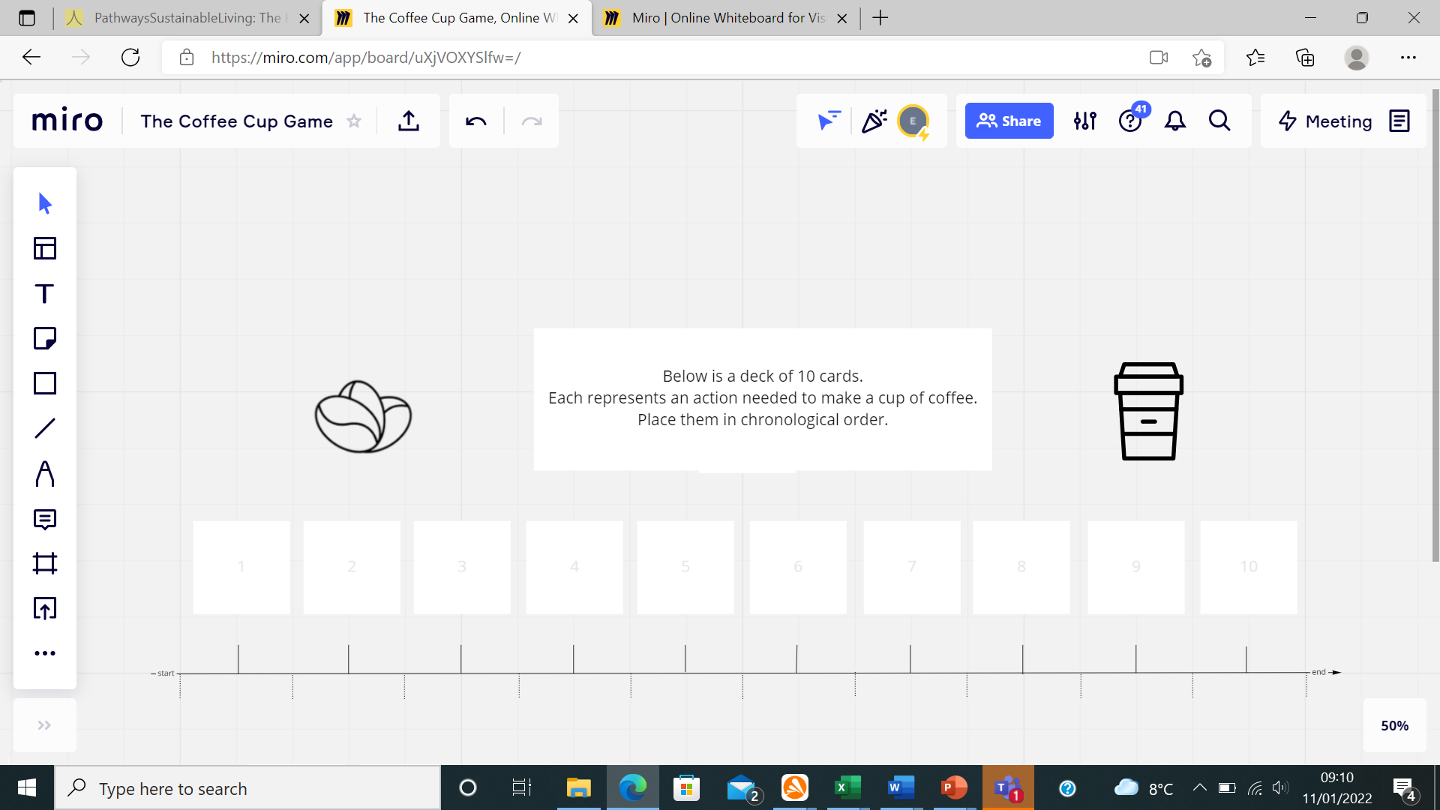

Round 1
Introduce the game as follows: “You are going to be shown 10 cards each representing an action needed to make a cup of coffee. Your task is to place these in the order they occur. We will go round the group, each person getting up to 30 seconds to place one card on the timeline, once you have placed your card I, the facilitator, will nominate someone else in the group who has not gone to place the next card. So please ensure now that your name is visible on zoom. As we go through you will start to understand the breadth of these actions so may want to change the position of previous cards as you place your own which is absolutely fine. If you have a comment on an action that is not your own you are welcome to discuss but the final decision will be down to whoever’s turn it is. Does that all make sense?’
To begin lift the instruction rectangle out of the way and there should be a virtual stack of cards below. When the group has decided where to place the card move it to the relevant square, this will simultaneously reveal the next card. Once all 10 cards have been placed ask the group are they happy? Move any as appropriate.

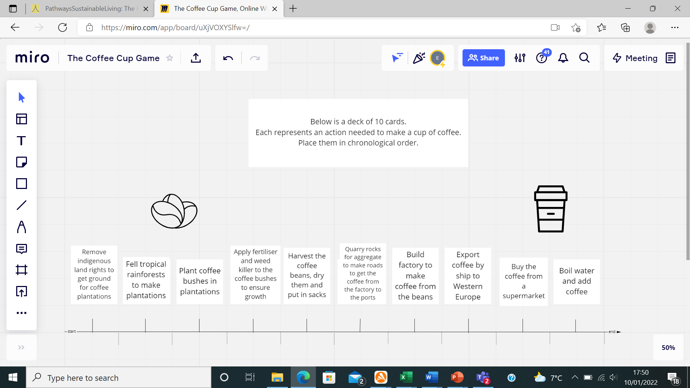

This is what the round 1 timeline should look like.
IF YOU HAVE MORE THAN 5 MINUTES UNTIL THE WORKSHOP IS OVER MOVE ONTO ROUND TWO, IF NOT SKIP STRAIGHT TO REFLECTION.
Round 2
Similar to round 1, round 2 consists of 10 cards that should be slotted into the existing timeline. There will be misconceptions here as some actions may take place over a number of years eg. Building a electrical plant to heat the water, therefore it is important to address this at the beginning by saying this: “Well done on getting through round 1 so quickly, we have enough time for a bonus round. Again you need to slot these 10 cards into the above timeline. Some of these actions may take place over a number of years so rather than considering when the action would need to be started consider when it needs to be completed for the process of making a cup of coffee to continue”. Some may also seem to take place at the same point eg. Heating the water and making crockery, please explain “it is ok in this round for more than one action to take place at the same point in the timeline- particularly those that feed into one action but are not themselves linked”.

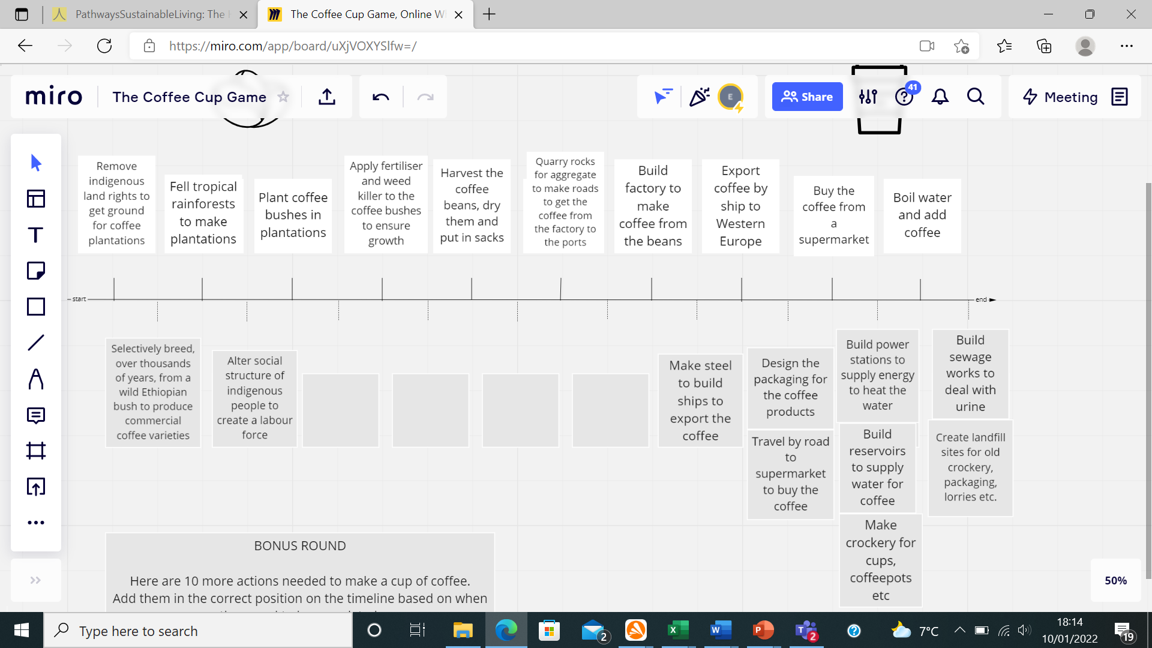

Reflections
To conclude pose the following questions for anyone in the group to answer:
- Did anything surprise you in that game?
- Do you think it’s useful from a sustainability perspective?
- Can you identify any key sustainability themes highlighted in our timeline? Any less obvious ones?
- Could you use this or a similar activity based on your curriculum area going forward and why?
Back to main group- done!

