EAUC Scotland
Public Bodies Climate Change Duties Report

2022/23 University Submissions
Emissions Analysis & Recommendations

April 2024

Contents
Executive Summary 3
Introduction 4
Reporting Quality 9
Analysis 11
Performance Metrics 17
Summary & RECOMMENDATIONS 17

Executive Summary
This analysis report covers university sector 2022/23 Public Bodies Climate Change Duties (PBCCD) reporting submissions. This was the second year that public bodies were expected to follow the Scottish Government’s Public Sector Leadership on the Global Climate Emergency.

Figure 1. Key figures for 2022/23
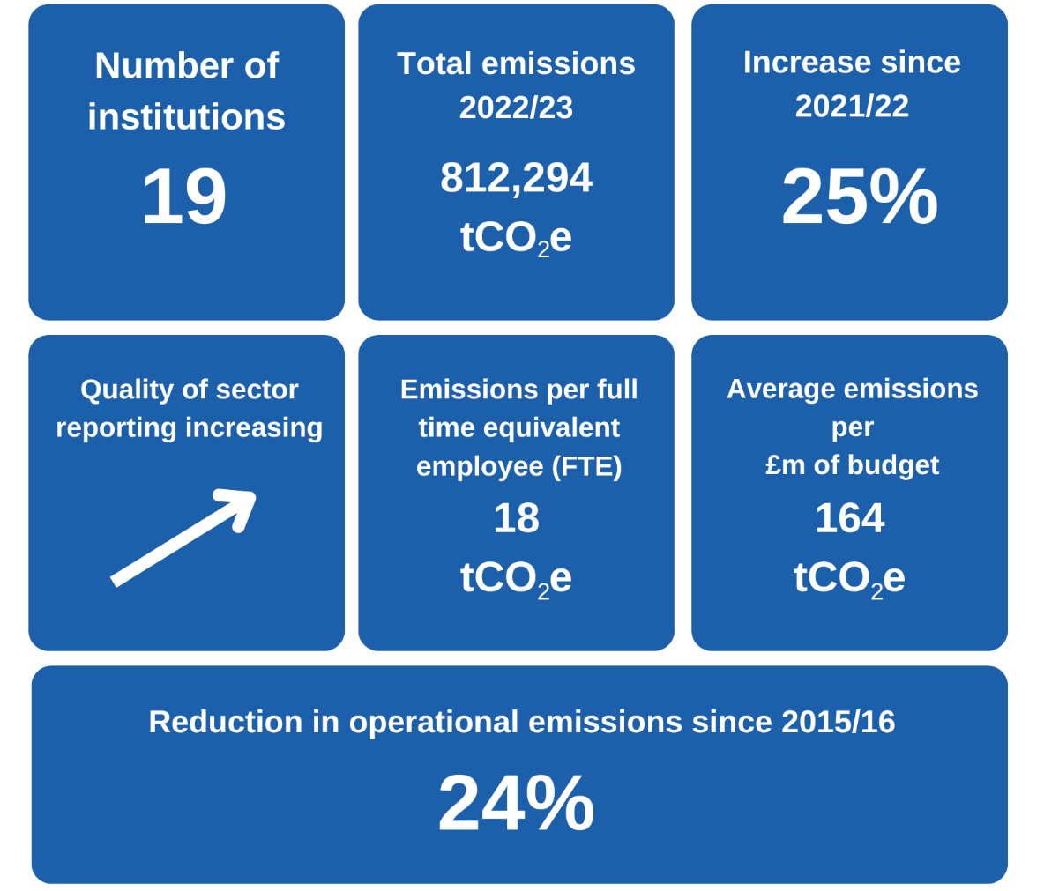

Total greenhouse gas (GHG) emissions for the university sector reported during 2022/23 were 812,294 tonnes of carbon dioxide equivalent (tCO₂e). Total reported emissions increased by 25% since 2021/22, predominantly due to increased reporting of Scope 3 emission sources (particularly supply chain and student relocation emissions) and increased emissions from business travel. Sector ‘operational emissions’ have reduced by 24% since 2015/16.

As the university sector fully meets the expectations set out in the Scottish Government’s Public Sector Leadership on the Global Climate Emergency, it is expected that reported Scope 3 emissions and total reported emissions will further increase significantly.

Average emissions per full time equivalent (FTE) employee were 18 tonnes of CO₂e and average emissions per million pounds of budget were 164 tonnes of CO₂e.
Alongside examples of best practice emissions reporting by some universities, this year there has been a significant improvement in the quality of reporting by the Scottish university sector as a whole. However, there remains some gaps in institutional target setting and reporting against the latest Scottish Government guidance.
Key trends and recommendations for the university sector include:
- Total Reported Emissions vs Improving Reporting Quality
Whilst there has been a 25% increase in reported emissions in 2022/23 compared to 2021/22, this is primarily due to increased quality of reporting by institutions and an increase in business travel flights by the sector. Previous reporting years, particularly for Scope 3 emissions, should be viewed as significantly under-reporting sector emissions.

- Priority Area 1: Expanding PBCCD Reporting
Whilst sector reporting has improved again over the past year, there remains a gap between current reporting and the expectations set out by Scottish Government. Universities should ensure that all relevant emission sources are included in 2023/24 PBCCD reports to be compliant of the guidance. A complete and transparent emissions profile for an institution will also support better informed decision-making for reducing emissions.

- Priority Area 2: Natural Gas Emissions
The university sector has made limited progress historically in reducing absolute emissions from natural gas. Over the past 8 years emissions from natural gas have reduced by 6%. However, with the Scottish Government expectation of zero direct emissions from public body estate buildings by 2038, the sector must focus efforts to understand, reduce and decarbonise heating emissions. Universities can apply for grant funding through the Scottish Green Public Sector Estate Decarbonisation scheme (GPSEDs).

- Priority Area 3: Business Travel Emissions
Business travel emissions have rebounded from 2020/21’s 1,848 tCO₂e to this 2022/23’s 48,502 tCO₂e. This remains significantly below pre-Covid 2018/19 emissions of 66,835 tCO₂e. The university sector and supporting sector agencies should look to lock-in changed travel habits and processes developed during Covid restrictions and ensure emissions from business travel do not continue to rise in future reporting years. With 88% of business travel emissions arising from flights in 2022/23, tackling this area should be an institutional focus where relevant.

- Priority Area 4: Supply Chain Engagement
Supply chain emissions represent 46% of reported sector emissions for 2022/23, despite only 63% of universities in Scotland reporting this emission source within their PBCCD return. The sector should proactively engage with their supply chains to improve sustainability understanding and action.

- EAUC Scotland Supporting the Sector
The training and peer review sessions that EAUC Scotland provided to institutions has resulted in better quality data and more key sources of emissions being reported. New tools and guidance include:
- Guide to the APUC Scope 3 Supply Chain Emissions Reporting Tool
- The Domestic and International Student Relocation Travel Emissions Calculator Tool

EAUC Scotland are also working with key stakeholders to develop new tools, guidance and sector leadership to tackle key emission areas. Upcoming activities will include:
- Launching Greenhouse gas emission reporting learning pack
- Launching Commuter emissions calculator and guidance

Priority actions for key university stakeholders:
- Actions for senior leaders:
- ensure robust and extensive institutional monitoring systems are in place to capture and report emissions from all relevant emission sources;
- understand the cost for decarbonising the institutional estate and ensure spending and investment strategies for the institution align with net zero obligations;
- understand the drivers for business travel within the institution and set emission reduction targets, as identified within Scottish Government guidance;
- update travel policies to include a ban on the use of flights for UK mainland domestic business travel, as identified within Scottish Government guidance;
- review university digital conferencing infrastructure.

- Actions for sustainability leads:
  - review Scottish Government guidance and current institutional PBCCD reporting; identify and address data and knowledge gaps for PBCCD submissions;
  - review business travel monitoring and work to address data gaps and/or improve data quality, ensuring PBCCD returns include a breakdown of all relevant business travel emission sources (e.g. fleet vehicle; private car; van; flight category);
  - establish internal groups and forums to share best practice in reducing the need for business travel;
  - ensure emissions data is transparent, accessible and publicly available on institutional webpages.

- Actions for sustainability and procurement leads:
- review current procurement strategies and ensure alignment with institutional sustainability objectives;
- use the APUC scope 3 supply chain emission tool (or similar) to report annual institutional supply chain emissions within PBCCD submissions;
- use frameworks and tools such as EcoVardis to review supply chain sustainability credentials alongside wider priorities (e.g. modern day slavery)

Introduction
As part of the Public Bodies Climate Change Duties (PBCCD), Scottish universities are expected to submit PBCCD reports to Scottish Government annually by the 30th November. This process has been mandatory since 2015/16. 19 universities submitted reports by the 30th November 2023 deadline, resulting in 100% sector compliance. All submitted reports can be found on the Sustainable Scotland Network website.
The data submitted predominantly covers the academic year 2022/23. This was the first year since 2018/19 that was not impacted by Covid-19 restrictions. This analysis report will summarise the data and provide comparisons between reporting periods for section three of the PBCCD reports.
Scotland’s world-leading climate change legislation set a target date for net zero emissions of all greenhouse gases (GHGs) by 2045. In 2020, the Climate Change (Duties of Public Bodies: Reporting Requirements) (Scotland) Amendment Order 2020 set out that from 2022 public bodies will also be required to annually report:
- Target date for achieving zero direct emissions of greenhouse gases;
- Targets for reducing indirect emissions of greenhouse gases; and
- How the body will align its spending plans and use of resources to contribute to reducing emissions and delivering its emissions reduction targets.
EAUC Scotland has continued to offer support to the Scottish Further & Higher Education (FHE) Sector to improve reporting. Over the past EAUC Scotland programme (2023-24) it included:
- Virtual training sessions on improving GHG emissions reporting;
- Group and one-to-one peer review sessions;
- Launch of the Guide to the APUC Scope 3 Supply Chain Emissions Reporting Tool
- Launch of The Domestic and International Student Relocation Travel Emissions Calculator Tool

Reporting Quality
As illustrated in Table 1, there continues to be a wide range of different operational reporting boundaries across the university sector.

Table 1. Percentage of institutions reporting each source of emissions
Emissions source | Number of universities reporting | Percentage of total | Change from 2021/22
Energy (natural gas; gas oil; biomass; other fuels) | 19 | 100% | =
F-gases | 11 | 58% | +3
Fleet vehicles | 13 | 68% | +1
Land use and livestock | 1 | 5% | =
Electricity | 19 | 100% | =
Transmission and distribution | 17 | 89% | =
Waste | 19 | 100% | =
Water | 19 | 100% | =
Business Travel | 18 | 95% | +2
Hotel stays | 8 | 42% | +4
Homeworking | 16 | 85% | =
Supply chains | 12 | 63% | +4
Commuting | 9 | 47% | +3
Student relocation | 6 | 32% | +2
Fuel- and energy related activities (WTT) | 2 | 11% | +1
Investments | 1 | 5% | =

The quality of the university reports has improved this year and some universities have expanded their reporting boundaries to include new emission sources for the first time, particularly for f-gases, emissions associated with travel and supply chains.

Overall, there remains a gap in the sector being compliant with Scottish Government’s Public Sector Leadership on the Global Climate Emergency guidance. Universities should report all relevant emission sources for 2023/24 PBCCD submissions. Note that the majority of the emission sources listed in Table 1 are relevant for all universities in Scotland.
Action: EAUC Scotland will continue to work with institutions to improve the quality of reporting and expand reporting boundaries in line with the Public Sector Leadership on the Global Climate Emergency guidance. The next sector PBCCD Peer Review session will be 6th November 2024 (online).

Emissions Data Analysis
Total reported emissions from the university sector in 2022/23 were 812,294 tCO₂e.
Figure 2: Breakdown of reported sector emissions by scope for 2022/23
As shown in Figure 2, in the reporting period 2022/23 Scope 1 sources accounted for 18% of total reported emissions, Scope 2 sources accounted of 8% of the reported total and Scope 3 sources accounted for the remaining 74%.

The majority of reported emissions arose from:
- Supply chains – 369,725 tCO₂e (46% of total reported emissions)
- Natural gas – 132,322 tCO₂e (16% of total reported emissions)
- Student relocation – 115,825 tCO₂e (14% of total reported emissions)
- Grid electricity consumption – 63,345 tCO₂e (8% of total reported emissions)
A full breakdown of reported emissions can be seen in Table 2.
Between 2021/22 and 2022/23 total reported emissions for the university sector increased by 162,225 tCO₂e, or 25% of total reported emissions. A breakdown of the percentage change in emissions for each source is shown in Table 3. The increase in reported emissions is predominantly due to expanded reporting by the sector of key Scope 3 emissions sources (namely supply chain and student relocation) which should be viewed positively. If the university sector meets the expectations set out in the Scottish Government’s Public Sector Leadership on the Global Climate Emergency, it is expected that reported Scope 3 emissions and total reported emissions will increase significantly again. An increase in sector business travel flights also contributed to the overall increase, with a reported rise of 33,000 tCO₂e between reporting years.

Noticeable emission trends beyond expanding reporting include:
- There has been a decrease in reported emissions from natural gas (-6%) and an increase in electricity emissions (+8%) between 2021/22 and 2022/23 reporting periods. These trends are likely to have been caused by a reduction in demand for natural gas through space management, energy efficiency upgrades, heat pump installations, an increase in use of electric fleet vehicles and increased carbon intensity of national grid electricity. Overall, since 2015/16, sector reported emissions from natural gas and electricity have reduced 5% and 56%, respectively.

- There has been a 44% reduction in reported fleet vehicle emissions between 2021/22 and 2022/23 reporting periods. Since 2015/16 reported fleet vehicle emissions have reduced 65%. It is expected that the majority of the observed reduction is from demand reduction and a significant increase in sector electric fleet vehicles.

- There has been a 213% increase in reported business travel between 2021/22 and 2022/23 reporting periods. This has been caused by a return to in-person international work, as shown by 88% of business travel emissions coming from international flights, and increasing domestic flight use (6% of business travel emissions). Since 2015/16 reported business travel emissions have reduced 38%.

Emissions source | Total reported emissions 2022/23  (tCO₂e) | Percentage of total reported emissions
Scope 1
Natural gas | 132,322 | 16.3%
Biomass | 242 | 0.0%
Gas oil | 1,270 | 0.2%
Other fuels | 550 | 0.1%
Fleet vehicles | 619 | 0.1%
F-gases | 1,482 | 0.2%
Land use and livestock | 11,358 | 1.4%
Subtotal | 147,842 | 18.2%
Scope 2
Grid electricity | 63,345 | 7.8%
Purchased heat and steam | 1,384 | 0.2%
Subtotal | 64,729 | 8.0%
Scope 3
Electricity transmission & distribution | 5,489 | 0.7%
Heat and steam transmission & distribution | 73 | 0.0%
Waste | 758 | 0.1%
Water (supply and treatment) | 726 | 0.1%
Business travel | 48,502 | 6.0%
Hotel stays | 3,459 | 0.4%
Homeworking | 5,298 | 0.7%
Commuting | 46,101 | 5.7%
Student relocation | 115,825 | 14.3%
Supply chain | 369,725 | 45.5%
Fuel- and energy related activities (WTT) | 3,713 | 0.5%
Investments | 55 | 0.0%
Subtotal | 599,723 | 73.8%
Total | 812,294 | 100.00%
Table 2: Reported Scottish university sector emissions 2022/23

Reported emissions (tCO2e) by reporting year
Emissions source | 2015/16 | 2016/17 | 2017/18 | 2018/19 | 2019/20 | 2020/21 | 2021/22 | 2022/23 | Change since 2021/22 | Change since 2015/16
Natural gas | 139,609 | 135,402 | 137,061 | 138,830 | 138,356 | 139,559 | 140,345 | 132,322 | -6% | -5%
Biomass | 94 | 138 | 112 | 556 | 817 | 771 | 181 | 242 | 34% | 157%
Other fuel | 2,986 | 1,494 | 2,220 | 1,967 | 2,076 | 3,868 | 1,319 | 1,820 | 38% | -39%
F-gases | 612 | 1,124 | 1,022 | 1,553 | 1,197 | 1,790 | 1,569 | 1,482 | -6% | 142%
Fleet vehicles | 1,782 | 1,446 | 1,358 | 1,387 | 883 | 1,148 | 1,098 | 619 | -44% | -65%
Land use & livestock | - | - | - | - | - | 11,616 | 11,624 | 11,358 | -2%
Electricity² | 156,003 | 135,848 | 105,050 | 86,697 | 71,521 | 64,220 | 63,700 | 68,834 | 8% | -56%
Purchased heat & steam² | - | - | - | - | - | 3,820 | 1,632 | 1,457 | -11%
Waste management | 3,076 | 2,288 | 2,052 | 2,287 | 1,791 | 1,592 | 719 | 758 | 5% | -75%
Water² | 2,663 | 2,716 | 2,630 | 2,532 | 2,347 | 539 | 669 | 726 | 9% | -73%
Business travel | 77,628 | 81,274 | 75,551 | 66,835 | 35,832 | 1,848 | 15,499 | 48,502 | 213% | -38%
Hotel stays | - | - | - | - | - | - | 901 | 3,459 | 284%
Commuting | 13,283 | 13,284 | 27,279 | 32,629 | 22,854 | 6,021 | 26,798 | 46,101 | 72% | 247%
Homeworking | - | - | - | - | - | 7,468 | 5,954 | 5,298 | -11%
Student relocation | - | - | - | 6,118 | 26,362 | 9,425 | 36,736 | 115,825 | 215%
Supply chain | - | - | - | - | 35,000 | 41,393 | 348,326 | 369,725 | 6%
Other² | 283 | - | 103 | 99 | 93 | - | 1,950 | 3,768 | 93% | 1231%
Total | 398,017 | 375,014 | 354,440 | 341,491 | 339,128 | 287,028 | 650,069 | 812,294 | 25% | 104%
Table 3: Comparison of reported Scottish university emissions between reporting periods

A comparison of total emissions broken down by scope between reporting periods is shown in Figure 3. This shows that since PBCCD reporting began in 2015/16:
- Reported scope 1 emissions have increased by 2%
- Reported scope 2 emissions have reduced by 55%
- Reported scope 3 emissions have increased by 449%

Figure 3: Comparison of reported Scottish university emissions broken down by scope between reporting periods 2015/16 to 2022/23.
The 2% increase in reported Scope 1 emissions is primarily due to expanded reporting of emissions by universities.

The 55% reduction in reported Scope 2 emissions since 2015/16 has been achieved through energy efficiency projects, renewables and the decarbonisation of the UK electricity grid, which has reduced grid carbon intensity by 50% over the past 8 years.

The 449% increase in reported Scope 3 emissions is due to expanded reporting of emissions by universities as shown in Table 3.

Total reported sector operational emissions have reduced by 24% since 2015/16 as shown in Figure 4. EAUC Scotland define ‘operational emissions’ as all scope 1 and 2 emissions, as well as scope 3 emissions from transmission and distribution, water supply and treatment, waste, business travel, hotel stays and homeworking.

Figure 4: Comparison of total reported Scottish university operational emissions between reporting periods 2015/16 to 2022/23.
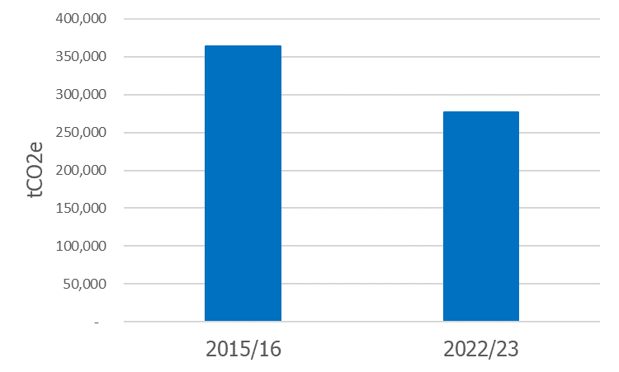

Action: EAUC Scotland will continue to support institutions to develop net zero plans, share best practice projects, signpost sources of funding and collaboration opportunities.

Performance Metrics
As shown in Table 4, average university sector emissions during 2022/23 were 164 tonnes of CO₂e per million pounds of budget and 18 tonnes of CO₂e per full time equivalent employee (FTE). These performance metrics have been modified from previous reporting periods to align with wider public sector reporting.

Table 4. Performance metrics for 2020/21 - 2022/23
Performance metrics | 2020/21 | 2021/22 | 2022/23
Universities
Budget (tCO2e/£m) | 65.7 | 117.5 | 164
Employees (tCO2e/FTE) | 6.1 | 11.3 | 18
Colleges
Budget (tCO2e/£m) | 43.0 | 71.0 | 123
Employees (tCO2e/FTE) | 2.9 | 10.5 | 9
FHE Sector
Budget (tCO2e/£m) | 53.0 | 90.6 | 158
Employees (tCO2e/FTE) | 4.3 | 10.9 | 16

These performance metrics will allow institutions to monitor relative progress between reporting periods and facilitate more meaningful comparison between similar institutions.

Action: EAUC Scotland will continue to encourage institutions to submit this data within PBCCD Reporting to improve the quality of the performance metrics.

Summary & Recommendations
2022/23 represents the eighth mandatory year of the Public Bodies Climate Change Duties Reporting for Scotland’s universities. Headline trends and recommendations to note:
- Total Reported Emissions vs Improving Reporting Quality
Whilst there has been a 25% increase in reported emissions in 2022/23 compared to 2021/22, this is primarily due to increased quality of reporting by institutions and an increase in business travel flights by the sector. Previous reporting years, particularly for Scope 3 emissions, should be viewed as significantly under-reporting sector emissions.

- Priority Area 1: Expanding PBCCD Reporting
Whilst sector reporting has improved again over the past year, there remains a gap between current reporting and the expectations set out by Scottish Government. Universities should ensure that all relevant emission sources are included in 2023/24 PBCCD reports to be compliant of the guidance. A complete and transparent emissions profile for an institution will also support better informed decision-making for reducing emissions.

- Priority Area 2: Natural Gas Emissions
The university sector has made limited progress historically in reducing absolute emissions from natural gas. Over the past 8 years emissions from natural gas have reduced by 6%. However, with the Scottish Government expectation of zero direct emissions from public body estate buildings by 2038, the sector must focus efforts to understand, reduce and decarbonise heating emissions. Universities can apply for grant funding through the Scottish Green Public Sector Estate Decarbonisation scheme (GPSEDs).

- Priority Area 3: Business Travel Emissions
Business travel emissions have rebounded from 2020/21’s 1,848 tCO₂e to this 2022/23’s 48,502 tCO₂e. This remains significantly below pre-Covid 2018/19 emissions of 66,835 tCO₂e. The university sector and supporting sector agencies should look to lock-in changed travel habits and processes developed during Covid restrictions and ensure emissions from business travel do not continue to rise in future reporting years. With 88% of business travel emissions arising from flights in 2022/23, tackling this area should be an institutional focus where relevant.

- Priority Area 4: Supply Chain Engagement
Supply chain emissions represent 46% of reported sector emissions for 2022/23, despite only 63% of universities in Scotland reporting this emission source within their PBCCD return. The sector should proactively engage with their supply chains to improve sustainability understanding and action.

- EAUC Scotland Supporting the Sector
The training and peer review sessions that EAUC Scotland provided to institutions has resulted in better quality data and more key sources of emissions being reported. New tools and guidance include:
- Guide to the APUC Scope 3 Supply Chain Emissions Reporting Tool
- The Domestic and International Student Relocation Travel Emissions Calculator Tool

EAUC Scotland are also working with key stakeholders to develop new tools, guidance and sector leadership to tackle key emission areas. Upcoming activities will include:
- Launching Greenhouse gas emission reporting learning pack
- Launching Commuter emissions calculator and guidance

Priority actions for key university stakeholders:
- Actions for senior leaders:
- ensure robust and extensive institutional monitoring systems are in place to capture and report emissions from all relevant emission sources;
- understand the cost for decarbonising the institutional estate and ensure spending and investment strategies for the institution align with net zero obligations;
- understand the drivers for business travel within the institution and set emission reduction targets, as identified within Scottish Government guidance;
- update travel policies to include a ban on the use of flights for UK mainland domestic business travel, as identified within Scottish Government guidance;
- review university digital conferencing infrastructure.

- Actions for sustainability leads:
  - review Scottish Government guidance and current institutional PBCCD reporting; identify and address data and knowledge gaps for PBCCD submissions;
  - review business travel monitoring and work to address data gaps and/or improve data quality, ensuring PBCCD returns include a breakdown of all relevant business travel emission sources (e.g. fleet vehicle; private car; van; flight category);
  - establish internal groups and forums to share best practice in reducing the need for business travel;
  - ensure emissions data is transparent, accessible and publicly available on institutional webpages.

- Actions for sustainability and procurement leads:
- review current procurement strategies and ensure alignment with institutional sustainability objectives;
- use the APUC scope 3 supply chain emission tool (or similar) to report annual institutional supply chain emissions within PBCCD submissions;
- use frameworks and tools such as EcoVardis to review supply chain sustainability credentials alongside wider priorities (e.g. modern day slavery)

Funders
This report has been published as part of EAUC Scotland’s Step-Change for Sustainability programme, funded by the Scottish Funding Council.

Contact us
We are a home-based organisation so please contact us by email at scotland@eauc.org.uk or info@eauc.org.uk. Our website can be found here. We are also available to reach via X (formerly Twitter) (EAUC, EAUC Scotland) and LinkedIn.

EAUC are a registered charity with the Charity Commission for England and Wales (No. 1106172). We are an incorporated company limited by guarantee, registered with Companies House (No. 5183502).

EAUC Scotland define ‘operational emissions’ as all scope 1 and 2 emissions, as well as scope 3 emissions from transmission and distribution, water supply and treatment, waste, business travel, hotel stays and homeworking.
² “Electricity” and “Purchased heat & steam” includes emissions associated generation and transmission and distribution losses; “Water” includes emissions associated with supply and wastewater treatment; “Other” includes reported emissions from investments and well-to-tank processes.

