EAUC Scotland
Public Bodies Climate Change Duties Report

2022/23 College Submissions
Emissions Analysis & Recommendations

April 2024

Contents
Executive Summary 3
Introduction 4
Reporting Quality 9
Analysis 11
Performance Metrics 17
Summary & RECOMMENDATIONS 17

Executive Summary
This analysis report covers college sector 2022/23 Public Bodies Climate Change Duties (PBCCD) reporting submissions. This was the second year that public bodies were expected to follow the Scottish Government’s Public Sector Leadership on the Global Climate Emergency.

Figure 1. Key figures for 2022/23
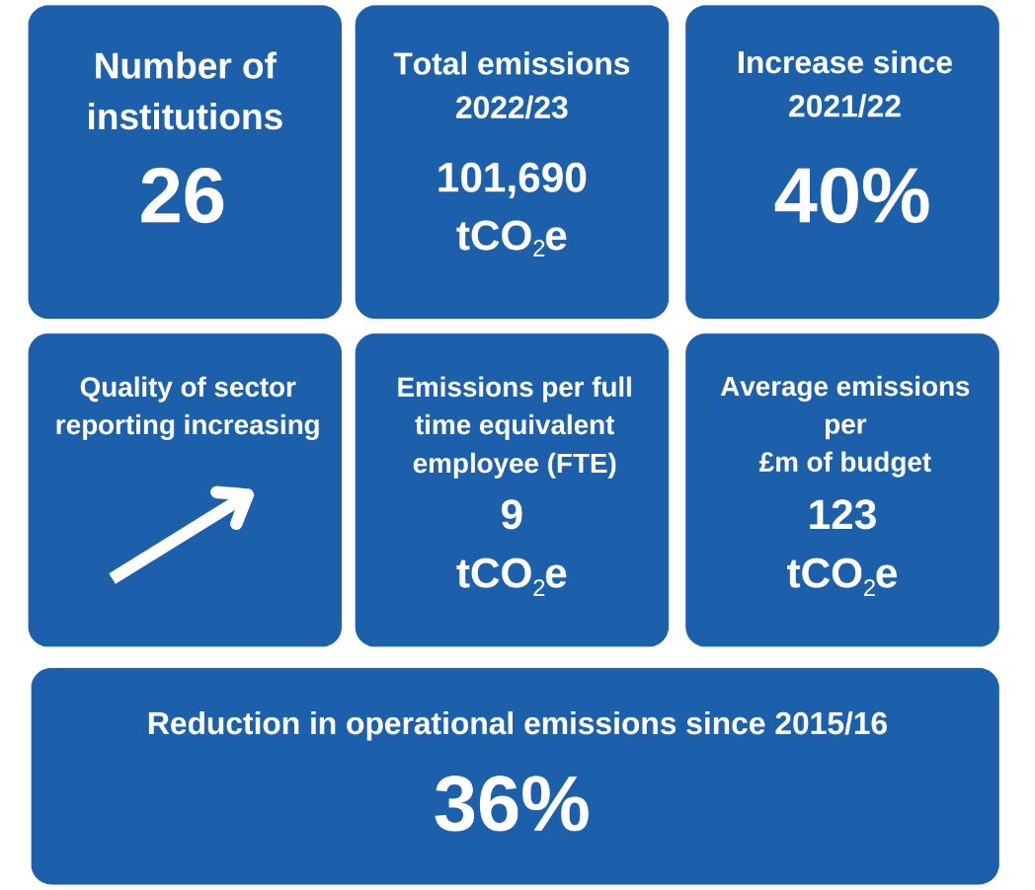

Total greenhouse gas (GHG) emissions for the college sector reported during 2022/23 were 101,690 tonnes of carbon dioxide equivalent (tCO₂e). Total reported emissions increased by 40% since 2021/22, predominantly due to increased reporting of Scope 3 emission sources (particularly supply chain and commuting emissions). Sector ‘operational emissions’ have reduced by 36% since 2015/16.

As the college sector fully meets the expectations set out in the Scottish Government’s Public Sector Leadership on the Global Climate Emergency, it is expected that reported Scope 3 emissions and total reported emissions will further increase significantly.

Average emissions per full time equivalent (FTE) employee were 9 tonnes of CO₂e and average emissions per million pounds of budget were 123 tonnes of CO₂e.
Whilst there are examples of best practice emissions reporting by some colleges, this year there has only been a small improvement in the quality of reporting by the Scottish college sector as a whole. As a result, there remains significant gaps in institutional target setting and reporting against the latest Scottish Government guidance.

Key trends and recommendations for the college sector include:
- Total Reported Emissions vs Improving Reporting Quality
Whilst there has been a 40% increase in reported emissions in 2022/23 compared to 2021/22, this is primarily due to increased quality of reporting by institutions. Previous reporting years, particularly for Scope 3 emissions, should be viewed as significantly under-reporting sector emissions.

- Priority Area 1: Expanding PBCCD Reporting
Whilst sector reporting has improved again over the past year, there remains a gap between current reporting and the expectations set out by Scottish Government. Colleges should ensure that all relevant emission sources are included in 2023/24 PBCCD reports to be compliant of the guidance. A complete and transparent emissions profile for an institution will also support better informed decision-making for reducing emissions.

- Priority Area 2: Natural Gas Emissions
The college sector has made some positive progress historically in reducing absolute emissions from natural gas. Over the past 8 years emissions from natural gas have reduced by 8%. However, with the Scottish Government expectation of zero direct emissions from public body estate buildings by 2038, the sector must focus efforts to understand, reduce and decarbonise heating emissions. Colleges can apply for grant funding through the Scottish Green Public Sector Estate Decarbonisation scheme (GPSEDs).

- Priority Area 3: Business Travel Emissions
Business travel emissions have rebounded from 2020/21’s 140 tCO₂e to this 2022/23’s 731 tCO₂e. This remains significantly below pre-Covid 2018/19 emissions of 1,693 tCO₂e. The college sector and supporting sector agencies should look to lock-in changed travel habits and processes developed during Covid restrictions and ensure emissions from business travel do not continue to rise in future reporting years. With 52% of business travel emissions arising from flights in 2022/23, tackling this area should be an institutional focus where relevant.

- Priority Area 4: Supply Chain Engagement
Supply chain emissions represent 52% of reported sector emissions for 2022/23, despite only 42% of colleges in Scotland reporting this emission source within their PBCCD return. The sector should proactively engage with their supply chains to improve sustainability understanding and action.

- EAUC Scotland Supporting the Sector
The training and peer review sessions that EAUC Scotland provided to institutions has resulted in better quality data and more key sources of emissions being reported. New tools and guidance include:
- Guide to the APUC Scope 3 Supply Chain Emissions Reporting Tool
- The Domestic and International Student Relocation Travel Emissions Calculator Tool

EAUC Scotland are also working with key stakeholders to develop new tools, guidance and sector leadership to tackle key emission areas. Upcoming activities will include:
- Launching Greenhouse gas emission reporting learning pack
- Launching Commuter emissions calculator and guidance

Priority actions for key college stakeholders:
- Actions for senior leaders:
- ensure robust and extensive institutional monitoring systems are in place to capture and report emissions from all relevant emission sources;
- understand the cost for decarbonising the institutional estate and ensure spending and investment strategies for the institution align with net zero obligations;
- understand the drivers for business travel within the institution and set emission reduction targets, as identified within Scottish Government guidance;
- update travel policies to include a ban on the use of flights for UK mainland domestic business travel, as identified within Scottish Government guidance;
- review college digital conferencing infrastructure.

- Actions for sustainability leads:
- review Scottish Government guidance and current institutional PBCCD reporting; identify and address data and knowledge gaps for PBCCD submissions;
- ensure PBCCD returns include a breakdown of all relevant business travel emission sources (e.g. fleet vehicle; private car; van; flight category);
- apply for grant funding from the Scottish Green Public Sector Estate Decarbonisation scheme (GPSEDs) to reduce scope 1 direct emissions.
- ensure emissions data is transparent, accessible and publicly available on institutional webpages.

- Actions for sustainability and procurement leads:
- review current procurement strategies and ensure alignment with institutional sustainability objectives;
- use the APUC scope 3 supply chain emission tool (or similar) to report annual institutional supply chain emissions within PBCCD submissions;
- use frameworks and tools such as EcoVardis to review supply chain sustainability credentials alongside wider priorities (e.g. modern day slavery)

Introduction
As part of the Public Bodies Climate Change Duties (PBCCD), Scottish colleges are expected to submit PBCCD reports to Scottish Government annually by the 30th November. This process has been mandatory since 2015/16. 25 Scottish colleges submitted reports by the 30th November 2023 deadline, resulting in 96% sector compliance. 1 college submitted their report after the deadline due to unforeseen circumstances. All submitted reports can be found on the Sustainable Scotland Network website.
The data submitted predominantly covers the academic year 2022/23. This was the first year since 2018/19 that was not impacted by Covid-19 restrictions. This analysis report will summarise the data and provide comparisons between reporting periods for section three of the PBCCD reports.
Scotland’s world-leading climate change legislation set a target date for net zero emissions of all greenhouse gases (GHGs) by 2045. In 2020, the Climate Change (Duties of Public Bodies: Reporting Requirements) (Scotland) Amendment Order 2020 set out that from 2022 public bodies will also be required to annually report:
- Target date for achieving zero direct emissions of greenhouse gases;
- Targets for reducing indirect emissions of greenhouse gases; and
- How the body will align its spending plans and use of resources to contribute to reducing emissions and delivering its emissions reduction targets.
EAUC Scotland has continued to offer support to the Scottish Further & Higher Education (FHE) Sector to improve reporting. Over the past EAUC Scotland programme (2023-24) it included:
- Virtual training sessions on improving GHG emissions reporting;
- Group and one-to-one peer review sessions;
- Launch of the Guide to the APUC Scope 3 Supply Chain Emissions Reporting Tool
- Launch of The Domestic and International Student Relocation Travel Emissions Calculator Tool

Reporting Quality
As illustrated in Table 1, there continues to be a wide range of different operational reporting boundaries across the college sector.

Table 1. Percentage of institutions reporting each source of emissions
Emissions source | Number of colleges reporting | Percentage of total | Change from 2021/22
Energy (natural gas; gas oil; biomass; other fuels) | 26 | 100% | =
F-gases | 12 | 46% | +6
Fleet vehicles | 14 | 54% | -1
Electricity | 26 | 100% | =
Transmission and distribution | 23 | 88% | +2
Waste | 23 | 88% | =
Water | 24 | 92% | +1
Business Travel | 21 | 81% | -2
Hotel stays | 5 | 19% | +5
Homeworking | 18 | 69% | -6
Supply chains | 11 | 42% | +3
Staff commuting | 6 | 23% | =
Student commuting | 4 | 15% | +1
Student relocation | 0 | 0% | =

Generally, the quality of the reports has improved again this year and some colleges have expanded their operational reporting boundaries to include new emission sources for the first time, particularly for f-gases.

However, the sector as a whole has not significantly improved the scope of reported emissions compared to 2021/22. This is despite the Scottish Government guidance for the public sector coming into play in 2022. In order to be compliant with the guidance, Scottish colleges should report all relevant emission sources for 2023/24 PBCCD submissions. Note that the majority of the emission sources listed in Table 1 are relevant for all colleges in Scotland.
Action: EAUC Scotland will continue to work with institutions to improve the quality of reporting and expand reporting boundaries in line with the Public Sector Leadership on the Global Climate Emergency guidance. The next sector PBCCD Peer Review session will be 6th November 2024 (online).

Emissions Data Analysis
Total reported emissions from the college sector in 2022/23 were 101,690 tCO₂e.
Figure 2: Breakdown of reported sector emissions by scope for 2022/23
As shown in Figure 2, in the reporting period 2022/23 Scope 1 sources accounted for 20% of total reported emissions, Scope 2 sources accounted of 12% of the reported total and Scope 3 sources accounted for the remaining 68%.

The majority of reported emissions arose from:
- Supply chains – 52,867 tCO₂e (52% of total reported emissions)
- Natural gas – 17,911 tCO₂e (18% of total reported emissions)
- Grid electricity consumption – 12,461 tCO₂e (12% of total reported emissions)
- Student commuting – 11,501 tCO₂e (11% of total reported emissions)
A full breakdown of reported emissions can be seen in Table 2.
Between 2021/22 and 2022/23 total reported emissions for the college sector increased by 29,058 tCO₂e, or 40% of total reported emissions. A breakdown of the percentage change in emissions for each source is shown in Table 3. The increase in reported emissions is predominantly due to expanded reporting by the sector of key Scope 3 emissions sources (namely supply chain and commuting) which should be viewed positively. If the college sector meets the expectations set out in the Scottish Government’s Public Sector Leadership on the Global Climate Emergency, it is expected that reported Scope 3 emissions and total reported emissions will increase significantly again.

Noticeable emission trends beyond expanding reporting include:
- There have been increases in reported emissions from natural gas (+1.9%) and electricity (+12.3%) between 2021/22 and 2022/23 reporting periods. This has been caused by increased sector demand (natural gas and electricity) and increased carbon intensity of national grid electricity (electricity only). The increase in energy demand over 2022/23 is expected to have been caused by a further return onsite operations post-Covid-19. This is supported by a significant reduction in reported homeworking emissions (-53%) between 2021/22 and 2022/23 reporting periods. Overall, since 2015/16, sector reported emissions from natural gas and electricity have reduced 7.9% and 56.4%, respectively.

- There has been a 21.3% reduction in reported fleet vehicle emissions between 2021/22 and 2022/23 reporting periods. Since 2015/16 reported fleet vehicle emissions have reduced 85.2%. Whilst part of this reduction is due to lower levels of fleet vehicle emissions reporting this year, the majority of the observed reduction is expected to be from demand reduction and a significant increase in sector electric fleet vehicles.

- There has been a 29.5% increase in reported business travel between 2021/22 and 2022/23 reporting periods. The observed increase is expected to have been caused by a further return onsite and wider college operations post-Covid-19. Of the total 731 tCO₂e reported business travel emissions, 52% were due to flights (12% domestic & 40% non-domestic) and 45% from car/van trips.

- There has been a 32.8% increase in reported waste emissions, respectively, between 2021/22 and 2022/23 reporting periods. The observed increase is expected to have been caused by a further return onsite and wider college operations post-Covid-19.

Table 2: Reported Scottish college sector emissions 2022/23
Emissions source | Total reported emissions 2022/23  (tCO₂e) | Percentage of total reported emissions
Scope 1
Natural gas | 17,911 | 17.6%
Biomass | 50 | 0.0%
Gas oil | 681 | 0.7%
Other fuels | 895 | 0.9%
Fleet vehicles | 150 | 0.1%
F-gases | 154 | 0.2%
Subtotal | 19,841 | 19.5%
Scope 2
Grid electricity | 12,461 | 12.3%
Subtotal | 12,461 | 12.3%
Scope 3
Electricity transmission & distribution | 1,077 | 1.1%
Waste | 410 | 0.4%
Water (supply and treatment) | 84 | 0.1%
Business travel | 731 | 0.7%
Hotel stays | 21 | 0.0%
Staff commuting | 1,921 | 1.9%
Student commuting | 11,501 | 11.3%
Homeworking | 776 | 0.8%
Supply chain | 52,867 | 52.0%
Subtotal | 69,388 | 68.2%
Total | 101,690 | 100.00%

Reported emissions (tCO2e) by reporting year
Emissions source | 2015/16 | 2016/17 | 2017/18 | 2018/19 | 2019/20 | 2020/21 | 2021/22 | 2022/23 | Change since 2021/22 | Change since 2015/16
Natural gas | 19,458 | 18,209 | 19,403 | 19,030 | 18,285 | 17,669 | 17,577 | 17,911 | 1.9% | -7.9%
Biomass | 54 | 64 | 101 | 121 | 112 | 84 | 56 | 50 | -11.5% | -8.2%
Other fuel | 1,545 | 1,610 | 1,790 | 1,745 | 851 | 1,169 | 1,157 | 1,576 | 36.3% | 2.0%
F-gases | - | - | - | 211 | 144 | 757 | 674 | 154 | -77.2% | -
Fleet vehicles | 1,018 | 325 | 236 | 422 | 228 | 130 | 191 | 150 | -21.3% | -85.2%
Electricity² | 31,030 | 26,734 | 21,048 | 18,374 | 14,712 | 11,698 | 12,051 | 13,537 | 12.3% | -56.4%
Purchased heat | - | - | - | - | - | - | 15 | - | - | -
Waste management | 728 | 661 | 622 | 591 | 277 | 240 | 309 | 410 | 32.8% | -43.6%
Water² | 370 | 364 | 388 | 330 | 350 | 77 | 84 | 84 | 0.0% | -77.3%
Business travel | 1,413 | 2,081 | 1,948 | 1,693 | 1,026 | 140 | 564.4 | 731 | 29.5% | -48.3%
Hotel stays | - | - | - | - | - | - | - | 21 | - | -
Commuting | - | - | - | 48 | 46 | 345 | 5,792 | 13,422 | 131.7% | -
Homeworking | - | - | - | - | - | 2,255 | 1,663 | 776 | -53.3% | -
Supply chain | - | - | - | - | - | - | 32,499 | 52,867 | 62.7% | -
Total | 55,615 | 50,049 | 45,536 | 42,563 | 36,033 | 34,563 | 72,632 | 101,690 | 40.0% | 82.8%
Table 3: Comparison of reported Scottish college emissions between reporting periods

A comparison of total emissions broken down by scope between reporting periods is shown in Figure 3. This shows that since PBCCD reporting began in 2015/16:
- Scope 1 emissions have reduced by 10%
- Scope 2 emissions have reduced by 57%
- Scope 3 emissions have increased by 1,328%

Figure 3: Comparison of reported Scottish college emissions broken down by scope between reporting periods 2015/16 to 2022/23.
Scope 1 emissions for 2022/23 increased by 2% compared to 2021/22, primarily due to increased use of natural gas as heating fuel and increased reporting and use of gas oil, petrol and diesel. Since 2015/16 reported emissions from heating fuels (natural gas, biomass and other heating fuels) have reduced by 7%.

The 57% reduction in Scope 2 emissions since 2015/16 has been achieved through energy efficiency projects, renewables and the decarbonisation of the UK electricity grid, which has reduced grid carbon intensity by 50% over the past 8 years. The 1,328% increase in Scope 3 emissions is due to expanded reporting of emissions by colleges.

Total reported sector operational emissions have reduced by 36% since 2015/16 as shown in Figure 4. EAUC Scotland define ‘operational emissions’ as all scope 1 and 2 emissions, as well as scope 3 emissions from transmission and distribution, water supply and treatment, waste, business travel, hotel stays and homeworking.

Figure 4: Comparison of total reported Scottish college operational emissions between reporting periods 2015/16 to 2022/23.
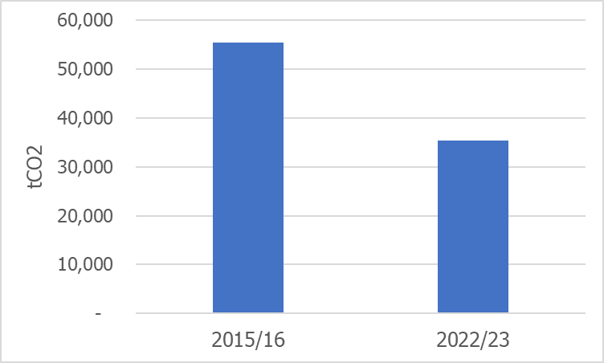

Action: EAUC Scotland will continue to support institutions to develop net zero plans, share best practice projects, signpost sources of funding and collaboration opportunities.

Performance Metrics
As shown in Table 4, average college sector emissions during 2022/23 were 123 tonnes of CO₂e per million pounds of budget and 9 tonnes of CO₂e per full time equivalent employee (FTE). These performance metrics have been modified from previous reporting periods to align with wider public sector reporting.

Table 4. Performance metrics for 2020/21 - 2022/23
Performance metrics | 2020/21 | 2021/22 | 2022/23
Universities
Budget (tCO2e/£m) | 65.7 | 117.5 | 164
Employees (tCO2e/FTE) | 6.1 | 11.3 | 18
Colleges
Budget (tCO2e/£m) | 43.0 | 71.0 | 123
Employees (tCO2e/FTE) | 2.9 | 10.5 | 9
FHE Sector
Budget (tCO2e/£m) | 53.0 | 90.6 | 158
Employees (tCO2e/FTE) | 4.3 | 10.9 | 16

These performance metrics will allow institutions to monitor relative progress between reporting periods and facilitate more meaningful comparison between similar institutions.

Action: EAUC Scotland will continue to encourage institutions to submit this data within PBCCD Reporting to improve the quality of the performance metrics.

Summary & Recommendations
2022/23 represents the eighth mandatory year of the Public Bodies Climate Change Duties Reporting for Scotland’s colleges. Headline trends and recommendations to note:
- Total Reported Emissions vs Improving Reporting Quality
Whilst there has been a 40% increase in reported emissions in 2022/23 compared to 2021/22, this is primarily due to increased quality of reporting by institutions. Previous reporting years, particularly for Scope 3 emissions, should be viewed as significantly under-reporting sector emissions.

- Priority Area 1: Expanding PBCCD Reporting
Whilst sector reporting has improved again over the past year, there remains a gap between current reporting and the expectations set out by Scottish Government. Colleges should ensure that all relevant emission sources are included in 2023/24 PBCCD reports to be compliant of the guidance. A complete and transparent emissions profile for an institution will also support better informed decision-making for reducing emissions.

- Priority Area 2: Natural Gas Emissions
The college sector has made some positive progress historically in reducing absolute emissions from natural gas. Over the past 8 years emissions from natural gas have reduced by 8%. However, with the Scottish Government expectation of zero direct emissions from public body estate buildings by 2038, the sector must focus efforts to understand, reduce and decarbonise heating emissions. Colleges can apply for grant funding through the Scottish Green Public Sector Estate Decarbonisation scheme (GPSEDs).

- Priority Area 3: Business Travel Emissions
Business travel emissions have rebounded from 2020/21’s 140 tCO₂e to this 2022/23’s 731 tCO₂e. This remains significantly below pre-Covid 2018/19 emissions of 1,693 tCO₂e. The college sector and supporting sector agencies should look to lock-in changed travel habits and processes developed during Covid restrictions and ensure emissions from business travel do not continue to rise in future reporting years. With 52% of business travel emissions arising from flights in 2022/23, tackling this area should be an institutional focus where relevant.

- Priority Area 4: Supply Chain Engagement
Supply chain emissions represent 52% of reported sector emissions for 2022/23, despite only 42% of colleges in Scotland reporting this emission source within their PBCCD return. The sector should proactively engage with their supply chains to improve sustainability understanding and action.

- EAUC Scotland Supporting the Sector
The training and peer review sessions that EAUC Scotland provided to institutions has resulted in better quality data and more key sources of emissions being reported. New tools and guidance include:
- Guide to the APUC Scope 3 Supply Chain Emissions Reporting Tool
- The Domestic and International Student Relocation Travel Emissions Calculator Tool

EAUC Scotland are also working with key stakeholders to develop new tools, guidance and sector leadership to tackle key emission areas. Upcoming activities will include:
- Launching Greenhouse gas emission reporting learning pack
- Launching Commuter emissions calculator and guidance

Priority actions for key college stakeholders:
- Actions for senior leaders:
- ensure robust and extensive institutional monitoring systems are in place to capture and report emissions from all relevant emission sources;
- understand the cost for decarbonising the institutional estate and ensure spending and investment strategies for the institution align with net zero obligations;
- understand the drivers for business travel within the institution and set emission reduction targets, as identified within Scottish Government guidance;
- update travel policies to include a ban on the use of flights for UK mainland domestic business travel, as identified within Scottish Government guidance;
- review college digital conferencing infrastructure.

- Actions for sustainability leads:
- review Scottish Government guidance and current institutional PBCCD reporting; identify and address data and knowledge gaps for PBCCD submissions;
- ensure PBCCD returns include a breakdown of all relevant business travel emission sources (e.g. fleet vehicle; private car; van; flight category);
- apply for grant funding from the Scottish Green Public Sector Estate Decarbonisation scheme (GPSEDs) to reduce scope 1 direct emissions.
- ensure emissions data is transparent, accessible and publicly available on institutional webpages.

- Actions for sustainability and procurement leads:
- review current procurement strategies and ensure alignment with institutional sustainability objectives;
- use the APUC scope 3 supply chain emission tool (or similar) to report annual institutional supply chain emissions within PBCCD submissions;
- use frameworks and tools such as EcoVardis to review supply chain sustainability credentials alongside wider priorities (e.g. modern day slavery)

Funders
This report has been published as part of EAUC Scotland’s Step-Change for Sustainability programme, funded by the Scottish Funding Council.

Contact us
We are a home-based organisation so please contact us by email at scotland@eauc.org.uk or info@eauc.org.uk. Our website can be found here. We are also available to reach via X (formerly Twitter) (EAUC, EAUC Scotland) and LinkedIn.

EAUC are a registered charity with the Charity Commission for England and Wales (No. 1106172). We are an incorporated company limited by guarantee, registered with Companies House (No. 5183502).

EAUC Scotland define ‘Operational emissions’ as all scope 1 and 2 emissions, as well as scope 3 emissions from transmission and distribution, water supply and treatment, waste, business travel, hotel stays and homeworking.
² Please note that “Electricity” includes emissions associated generation and transmission and distribution losses; “Water” includes emissions associated with supply and wastewater treatment.

